Vamos a estructurar tu paper

**Referencias:**

[**How to Write and Publish a Scientific Paper**](https://books.google.com.mx/books/about/How_to_Write_and_Publish_a_Scientific_Pa.html?hl=&id=2a0XBLl8GPwC&redir_esc=y)

[Science Research Writing: For Native and Non-native Speakers of English](https://play.google.com/store/books/details?id=WkcREAAAQBAJ)

Introduction – Method – Results – and – Discussion: IMRaD

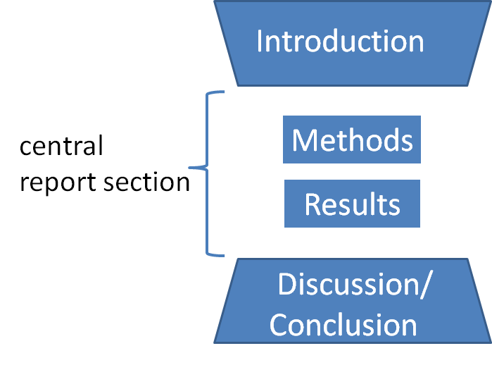

## **Introduction:** Why was the study undertaken? What was the research question, the tested hypothesis, or the purpose of the research?

## **Methods:** When, where, and how was the study done? What materials were used, or who was included in the study groups (patients, etc.)?

## **Results**: What answer was found to the research question; what did the study find? Was the tested hypothesis true?

**Discussion**: What might the answer imply, and why does it matter? How does it fit in with what other researchers have found? What are the perspectives for future research?

Nota: Aunque la revista de lo permita separa siempre: **Results Discussion, Conclusions**. Esto mejora tu estructura y permite presentar las ideas más claramente. Si tienes que cambiar de paper. No tienes que rescribir.

